Year |  | Stage 2 (Years 3 & 4) and Stage 3 (Years 5 & 6) Maths Facts
Stage 3 | Prime and Composite Numbers
A prime number is a number that has only two factors- itself and one, e.g. 2, 3, 5, 7 etc.
A composite number is a number that has more than two e.g. 4, 6, 8, 9, 10 etc.
Stage 2 & 3 | Squares and Square Roots
 | 1²= 1  2²=4  3²=9  4²=16  5²=25 |  | 6²=36  7²=49  8²=64  9²=81  10²=100 | √9= 3  √16=4  √64=8  √81=9  √100=10
Stage 2 & 3 | Mental Computation
Stage 2 & 3 | Decimals
 | Examples of the types of questions that may be asked: |  | 1/10 = 0.1  ¼ = 0.25  ½ = 0.5  ¾ = 0.75  1/5 = 2/10 =0.2 | 1/ 100 = 0.01  57/ 100 = 0.57  163/100 = 1.63  2/1000 = 0.002  179/ 1000 = 0.179
Stage 2 & 3 | Symbols
 | x = multiplication  >= is greater than  <= is less than |  | a/b a= numerator  a/b b= denominator
Stage 2 & 3 | Number combinations (using knowledge of number strategies to solve quickly in your head)
 | Examples of the types of questions that may be asked: |  | 36 + 42 = 30+40+6+2  = 70 + 8  = 78
Stage 2 & 3 | Metric Symbols
 | HINT: Kilo= thousand, Centi= hundred, Milli- thousand
 | ml= millilitre  l=litre  g=gram  t=tonne  kg=kilogram  cm=centimetre |  | m=metre  km=kilometre  cm²= square centimetre  km/h=kilometres per hour  min=minutes
Stage 2 & 3 | Measurement conversions
 | 1000mm=1m  100cm=1m  1000=1km  10mm=1cm |  | 1000g=1kg  1000kg=1tonne | 1000ml=1 litre  1000litres= 1 kilolitre
Stage 2 & 3 | Time
 | 60seconds=1 minute  60minutes=1hour  24hours=1 day  7days=1 week |  | 4 weeks= 1 month  52 weeks= 1 year  10 years= 1 decade  12 months= 1 year | 365 days= 1 year  366 days= 1 leap year  10 decades or 100 years=1 century
Stage 2 & 3 | Seasons
Spring- September, October, November
Summer- December, January, February
Autumn- March, April, May
Winter- June, July, August
Stage 2 & 3 | Area and Perimeter
 | Area – square or rectangle  Area = length x breadth |  | Perimeter- square or rectangle  Perimeter= sum of the sides.
Stage 3 | Parts of a circle
 | 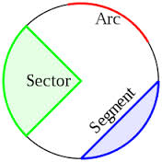 |  |  | 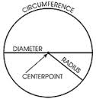
Stage 3 | Types of angles
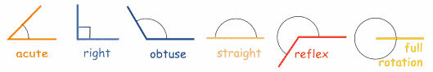
Less than 90 90 degrees between 90 180 degrees greater than 180 360 degrees
degrees and 180 degrees degrees

** Questions will vary and include – identifying/recognising, labelling/naming, writing numerals in word/number form, number sequences, missing values, number problems, comparisons/identifying measurements, combinations of operations.
We challenge you to keep testing your knowledge of the facts above by practising some questions/problems based on them to prepare for the Maths Championships.

